Lab Exercise: ISO 27002 Compliance Mapping
Phase 1: Importing the Compliance Package
Before you can map anything, Eramba needs the "library" of requirements.
- Navigate to Compliance Management > Compliance Packages.
- Click Actions > Download from Community.
  - Note: If your instance isn't connected to the internet, you would manually upload the ISO 27002:2022 CSV file here.
- Search for ISO 27002:2022 (Annex A) and click Import.
- Once imported, go to the Compliance Package Items tab. You should now see the full list of controls (e.g., 5.1, 5.2, 8.1, etc.).

Phase 2: Creating the "Solutions"
We need two solutions to map to our requirements: a document and an activity.
Step A: Create a Policy (The Document)
- Go to Policy Management > Policies.
- Click Add New.
- Title: "Information Security Policy v1.0".
- Owner: Select yourself or a demo "IT Security" group.
- Save the policy.
Step B: Create an Internal Control (The Activity)
- Go to Internal Controls > Internal Controls.
- Click Add New.
- Title: "Monthly User Access Review".
- Description: "Managers review access logs for their teams every 30 days."
- Owner: Select "IT Operations".
- Save the control.

Phase 3: The Compliance Analysis (Mapping)
Now we tell Eramba that these solutions satisfy the ISO requirements.
- Navigate to Compliance Management > Compliance Analysis.
- Find the ISO 27002 package in the list and click into it.
- Scenario 1: Mapping a Policy
  - Locate requirement 5.1 (Policies for Information Security).
  - Click Edit or the Mapping icon for that row.
  - In the Policy field, search for and select your "Information Security Policy v1.0".
- Scenario 2: Mapping an Internal Control
  - Locate requirement 8.2 (Privileged Access Rights).
  - Click Edit or the Mapping icon for that row.
  - In the Internal Control field, search for and select your "Monthly User Access Review".

Phase 4: Verification (The Result)
Check the Compliance Analysis Dashboard. You will notice:
- Requirements 5.1 and 8.2 now show a Status.
- If your Policy has an upcoming review date and your Internal Control has a successful "Audit" logged, the status will be Green (Compliant).
- If the Control has never been audited, Eramba will likely flag it as Yellow/Red, indicating that while you have a solution, you haven't proven it works yet.

Create compliance package
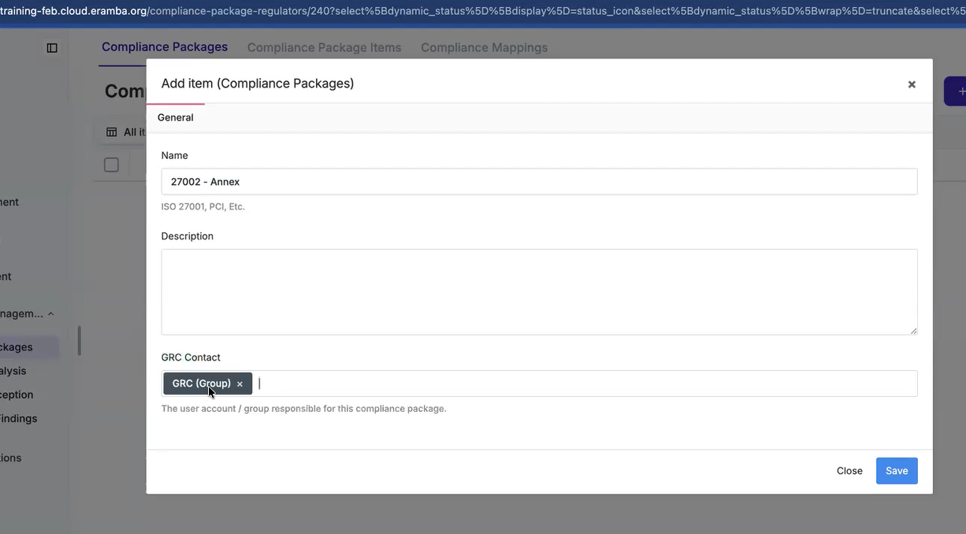

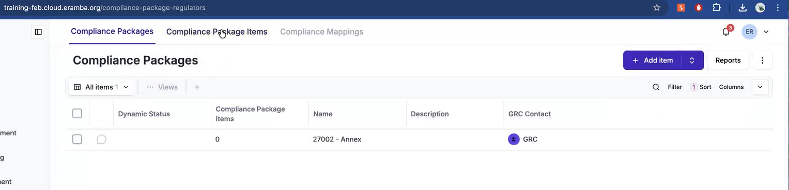
Import compliance package item

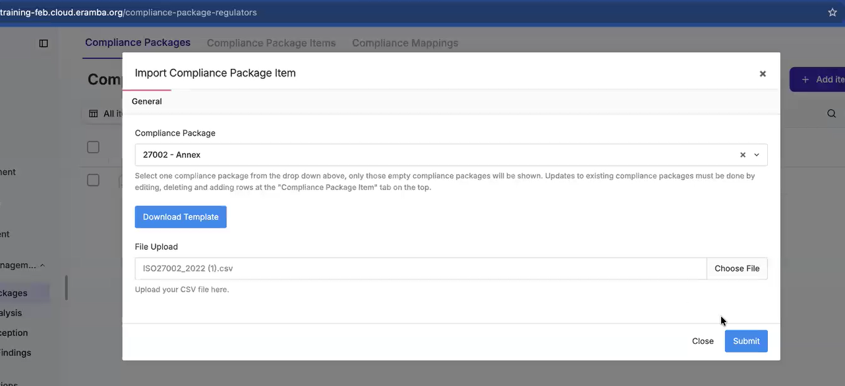
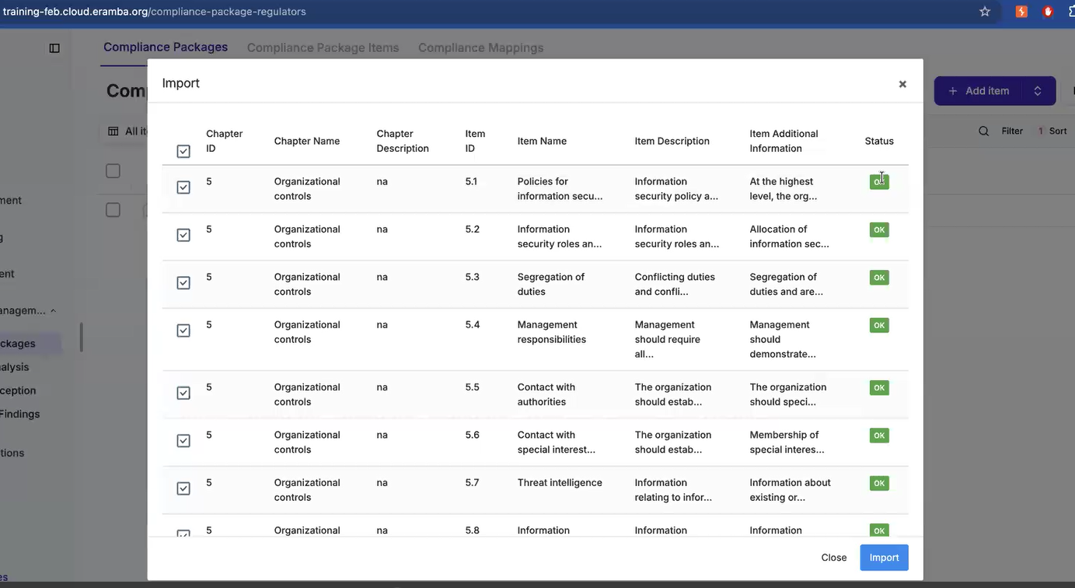
After import is completed, the package appears like seen below
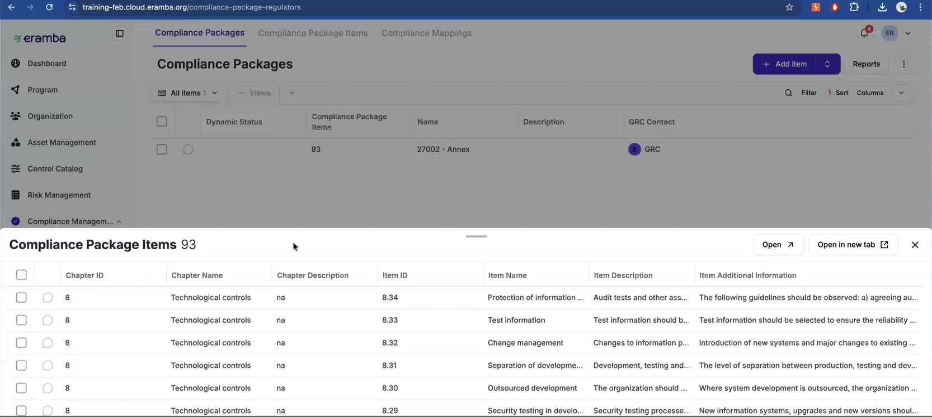
We are finding a solution to the problem in this example, problem is 5.1 Policies for information security and solution is adding security policy – information security policy.

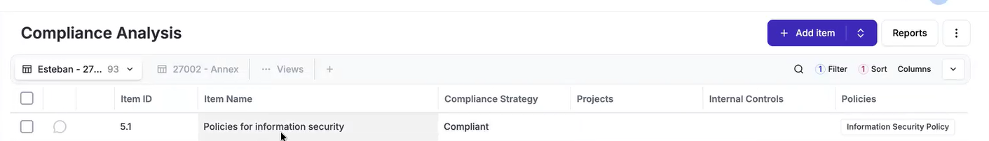
If we same solution applies to different problems then we will leverage same solution for those problems like seen below
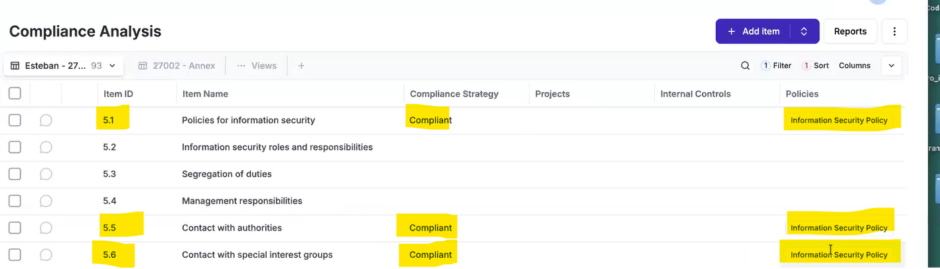
If the solution for the problem is just the paper work we will handle it through security policies module.
If the solution for the problem is achieved by doing an activity then we will handle that through the internal controls module.
